**ACKNOWLEDGEMENT**

We take this occasion to thank our parents for their consistent support and encouragement. We are immensely thankful to our college, **Himalaya College of Engineering**, for including the project in the syllabus. We are also very grateful for the college for providing us with this opportunity. Furthermore, we extend our sincere and heartfelt thanks to our Head of Department, **Er. Himal** **Chand Thapa**, for providing us with the right guidance and for showing us the right way. We would like to express our deep gratitude towards **Er. Ashok GM** as well as other faculty members for their proper guidance and inspiration. Finally, we would like to give special thanks to acknowledge all the people who have helped us towards the development of this proposal.

**Group Members:**

Bishal Bhatta[2075/BSCCSIT/20943]

Bishwa Nath Pokhrel [2075/BSCCSIT/20944]

Isha Bhandari [2075/BSCCSIT/20949]

**ABSTRACT**

Face recognition is among the most productive image processing applications and has a pivotal role in the technical field. Recognition of the human face is an active issue for authentication purposes specifically in the context of attendance of students. Attendance system using face recognition is a procedure of recognizing students by using face biostatistics based on the high definition monitoring and other computer technologies. The development of this system is aimed to accomplish digitization of the traditional system of taking attendance by calling names and maintaining pen-paper records. Present strategies for taking attendance are tedious and time-consuming. Attendance records can be easily manipulated by manual recording. The traditional process of making attendance and biometric systems has less accuracy. This system makes the use of Haar-classifiers, CNN and VGG model. After face recognition attendance reports is generated and stored in database and shown in the web application. We used SQLLite3 to make, update, delete, edit and display the database. We used tkinter library to create a user interface. System proved to be an efficient and robust device for taking attendance in a classroom without any time consumption and manual work.

**Keywords: CNN, Haar-Classifier, Tkinter, VGG**

**Contents**

**List of figure** i

**List of Tables** ii

**Abbreviation** iii

**CHAPTER 1: INTRODUCTION** 1

**1.1 Introduction** 1

**1.2 Problem Definitions** 2

**1.3 Objectives** 2

**1.4 Scope and Limitations** 3

**1.5 Report Organization** 4

**CHAPTER 2: LITERATURE REVIEW** 5

**2.1 Previously related works** 5

**2.1.1 Smart attendance using real time face recognition(smart-FR)** 5

**2.1.2 A real time face recognition system using PCA and various distance classifiers** 6

**2.1.3 Face recognition Using improved fast PCA Algorithm** 6

**2.1.4 Face recognition system using Artificial Neural Network** 6

**Chapter 3: Requirement Analysis and Feasibility study** 7

**3.1 Requirement Analysis** 7

**3.1.1 Functional requirement** 7

**3.2 Use case diagram** 7

**3.3 Feasibility Study** 8

**3.3.1 Technical Feasibility** 8

**3.3.2 Economic Feasibility** 8

**3.3.3 Legal Feasibility** 8

**3.3.4 Operational Feasibility** 8

**3.4 Structuring System Requirements** 10

**CHAPTER 4: SYSTEM DESIGN** 12

**4.1 Sequence Diagram** 12

**Face detection algorithm with Viola-Jones algorithm:** 14

**Face recognition using convolutional neural network** 16

**CHAPTER 5: IMPLEMENTATION AND TESTING** 20

**5.1 Implementation** 20

**5.1.1 Tools used** 20

**Back End:** 20

**5.2 Testing** 21

**5.2.1 Unit Testing** 21

**5.2.2 Integration Testing** 22

**5.2.3 System testing** 25

**5.3 Result Analysis** 26

**CHAPTER 6: CONCLUSION AND RECOMMENDATION** 32

**6.1 CONCLUSION** 32

**6.2 RECOMMENDATION** 32

**References** 33

**APPENDICES:** 34

# **List of figure**

Fig 3.1 USE CASE DIAGRAM 7

Fig:3.2 Gantt chart 9

Fig 3.3 DFD LEVEL 0 10

Fig 3.4 DFD LEVEL 1 11

Fig 4.1 SEQUENCE DIAGRAM 12

Fig4.1: Haar- Features in Voila -Jones Algorithm 14

Fig: 4.2 integral image 15

Fig 4.3: Convolutional neural network. 16

Fig 5.1: Test 1 Fig 5.2: Test 2 21

Fig 5.3: Test3 Fig 5.4: Test4 22

Fig 5.5: Test 5 Fig5.6: Test6 23

Fig5.7: test 7 24

Fig5.8: Test8 24

Fig5.9 Test 9 25

Fig5.10: Test10 25

Fig 5.11: training accuracy of model 26

Fig5.12: Without Haar-classifier 27

Fig 5.13: With Haar-classifier 27

Fig 5.14: Without Haar- Classifier 28

Fig5.15: With Haar-Classifier 28

Fig5.16: Without Haar-classifier 29

Fig5.17: With Haar-classifier 29

Fig 5.18: Dataset of Bishal 30

Fig 5.19: Dataset of Bishwa 30

Fig: 5.20: Dataset of Isha 30

# **List of Tables**

Table5.1: Valid Registration Unit Table 21

Table 5.2: Integration test of system 22

Table 5.3: Integration test of system 23

# **Abbreviation**

CNN: Convolutional Neural Network

RFID: Radio Frequency Identification

PCA: Principle Component Analysis

HOG: Histogram of Oriented Gradient

DFD: Data Flow Diagram

VGG: Visual Geometry Group

# **CHAPTER 1: INTRODUCTION**

## **1.1 Introduction**

The Attendance System using Face Recognition system is a replacement way method for the traditional way of marking the attendance. This system can be implemented on any faculty system of a particular institute. This system is based on biometrics i.e. Face Recognition. Since there is a presence of biometrics, this system completely eliminates the chance of fake attendance which is a problem with the traditional method of attendance.

The attendance system is the significant process that were carry out in every institute to monitor the performance of the students. Every institute does this in its own way. Some of the institute use the old paper or file-based system and some have adopted strategies of automated attendance system using some biometric technique. An attendance system using facial recognition system is a computerized software which is suited for determining or validating a person by performing comparisons on the pattern based on their facial appearances. The process of facial recognition mainly contains the two parts:

1. Face detection

It is the process of finding the human facial image for the easier recognition.

1. Face recognition

In this step the detected and processed face is compared to the dataset of known faces to decide who that person is.

In this system the system will capture the student photos and store them into the database which were further used for the training purpose after that at the time of attendance when system camera gets on, the system will detect the faces that were present in the frame by using the face detection algorithm i.e. Viola Jones algorithm. So at last by using the CNN algorithm system will find the person in the database (i.e. captured in the starting of the project) who has the closet measurements to the image that were detected by camera. After finding the perfect match system will generate the name and date and time and present mark and store the entry in CSV file. Which were further uploaded on the database. The motivation behind this project is to simplify the means by which attendance is taken in the institute. With the face detection and recognition system in place, it will be easy to tell if a student is actually present in the institution or not.

## **1.2 Problem Definitions**

Attendance is an important part of daily classroom evaluation. At the beginning and ending of class, it is usually checked by the teacher, but it may appear that a teacher may miss someone or some students answer multiple times. There exists a Radio Frequency Identification (RFID) based system, students carry a RFID tag type ID card and they need to place that on the card reader to record their attendance. This system may give rise to the problem of fraudulent access. Unauthorized person may make use of authorized ID card and enter the organization. Similarly, Fingerprint based Attendance System has a fingerprint device where the students place their finger on the sensor. The problem with this approach is that it couldn’t identify if the person in case of a cut or wound or when fingerprints are smudged with dirt or grease.

Adopting a face recognition attendance system can eliminate all the above-listed disadvantages of the attendance system. The concept of face recognition is to give a computer system the ability of finding and recognizing human faces fast and precise manners. Numerous algorithms and techniques have been developed for improving the performance of face recognition. The face recognition is an integral part of biometrics. In biometrics, basic traits of human are matched to the existing data. Facial features are extracted and implemented through algorithms. Additionally, this system does not depend on custom hardware to record attendance.

## **1.3 Objectives**

1. To detect and recognize the biometric face of the users using Haar Classifier and CNN algorithm.
2. To automate the process of tracking and organizing the attendance sheet without human intervention.

## **1.4 Scope and Limitations**

A student attendance management system helps to track and store the attendance data in real-time. Besides student attendance, the system also helps school admins in maintaining and tracking leaves applications, arrival & departure times of students. The face detection includes better security, easy integration, and automated identification.

However, the limitations cannot be neglected too. Limitations which we may have to face can be of different kinds such as:

* Image quality

The quality of the reference image plays an important role in the identification process. If the resolution of the said image is not high enough, it can cause cameras to be tricked into believing that the person being scanned is not the same as in the photo. An easy solution is to ensure that both the reference images and scanning are performed by similar cameras.

* Storage

Depending on the quality of the input data, a system would need an appropriate amount of storage. This could be troublesome if the data collected is of high quality and requires large amounts of storage space especially for events with a large expected attendance.

* Angles

Many non-premium facial recognition systems cannot account for faces that are captured at angles other than straight into the capturing camera. The disadvantage of this is that it makes the attendance marking process slower and less efficient.

## **1.5 Report Organization**

This shows the total overview and the organization flow of the report.

**CHAPTER 1 Introduction:** This chapter consists of a background portion along with objectives and problem definition with scope and limitations of the project.

**CHAPTER 2 Literature Review:** This chapter includes the literature review of the project.

**CHAPTER 3 Requirement Analysis and Feasibility Study:** This chapter contains the requirement analysis and feasibility study with structure system requirement and all the necessary diagrams.

**CHAPTER 4 System Design:** This chapter contains system design with sequence diagram and necessary algorithm.

**CHAPTER 5 Implementation and Testing**: This chapter contains the possible results of the whole system.

**CHAPTER 6 Conclusion and Recommendation** : This chapter contains the conclusion with the snapshots of the system.

# **CHAPTER 2: LITERATURE REVIEW**

In recent times, different techniques, methods and algorithms have been used to perform facial recognition and increase the accuracy of facial recognition. The authors developed a real-time multiple face recognition system using deep learning on embedded GPU [1]. Convolutional Neural Network (CNN) based face recognition with face tracking and deep CNN face recognition algorithm have been used for the system. An automatic student attendance system was proposed that can be utilized in small and crowded classrooms [2]. In this model, after the training stage, the user, e.g. the teacher, can get the attendance by taking one or multiple images of the classroom using his/her smartphone. The implemented system detects the faces in the images and recognizes which students are present in order to mark the attendance. But real-time video attendance was not possible with this system. The Bilateral Filter, Haar-like features [3] techniques were applied to identify the model of the human face [4]. An automatic attendance management system was proposed using face recognition algorithms [5]. A camera at the doorway captures students image while entering into the class. But, that system faced limitations as it could not define two persons at the same time. For the proposed system, we have used CNN architecture to detect faces and train the system.

The system starts by capturing the student’s facial data and storing them with their appropriate labels to create a dataset. For recognizing faces, CNN model is used. Although Histogram of Oriented Gradient (HOG) method can also be used for detecting the faces, this method is less accurate than CNN and also requires the captured face to be completely straight in relation to the camera in order to be detected. The dataset is then trained for the next step. The system then analyzes the image and detects the faces of the students present in the classroom. The detected faces are then compared to those from the trained dataset. This is the recognition stage. The recognized student’s data is then saved in an excel sheet, which marks their attendance.

## **2.1 Previously related works**

### **2.1.1 Smart attendance using real time face recognition(smart-FR)**

This system represents an automated human face recognition in a real time. Smart Attendance using Real Time Face Recognition is a real world solution which comes with day to day activities of handling employees. The task is very difficult as the real time background subtraction in an image is still a challenge. To detect real time human face Haar cascade is used and a simple fast Principal Component Analysis is used to recognize the faces detected with a high accuracy rate. The matched face is then used to mark attendance of the employees. Addition to this there is a method to handle employee leaving request through Natural Language Processing by approving or rejecting leaves and replies for all requests. This product gives much more solutions with accurate results in user interactive manner rather than existing attendance and leave management systems. [6]

## **2.1.2 A real time face recognition system using PCA and various distance classifiers**

Face recognition is an important application of image Processing owing to its use in many fields. The project presented here was developed after the studies of various face recognition methods and their efficiencies. The effective and real time face recognition system based on Open CV and C++ is developed in the project. The system was tested on YALE face database B and ORL Face Database. The recognition produced using 3 different matching techniques are compared and the results have been presented. The correct recognition rate achieved using Mahalanobis distance is 92.3% in comparison to the 73.1% for the normal PCA with Euclidean distance. The system responds to the face recognition queries inn less than 0.2 seconds. [7]]

## **2.1.3 Face recognition Using improved fast PCA Algorithm**

The project is presenting improved fast PCA algorithm which is using geometry and symmetry of faces. The feature of faces will be extracted using fast Fuzzy Edge Detection to locate the vital feature points on eyes, nose and mouth. Then subgroup of database image is formed and when it comes to recognition part, only the image falling in same group will be transform into image vectors in covariance matrix. For this well-known histogram equalization is applied which results in contrast adjusted images by increasing the local contrast. [8]

## **2.1.4 Face recognition system using Artificial Neural Network**

The project is about Artificial Intelligent technique where the system is designed to recognize the pattern of faces in input image. The system uses the artificial neural network that come with MATLAB. The target output in the project is face pattern. Hence, the desired output supposed to be all of face available. The neural network will calculate and recognize pixel by pixel input image based on the edge detection image processing technique. [9]

# **CHAPTER 3: Requirement Analysis and Feasibility Study**

## **3.1 Requirement Analysis**

### **3.1.1 Functional requirement**

* Login: The staffs need to login the system.
* Face recognition: The system recognizes face biometric of the users.
* Attendance: The system increments the attendance of the user with timestamp.
* Attendance Operation: The staffs are able to add or update the biometric information.
* Logout: The staff need to logout the system

## **3.2 Use case diagram**

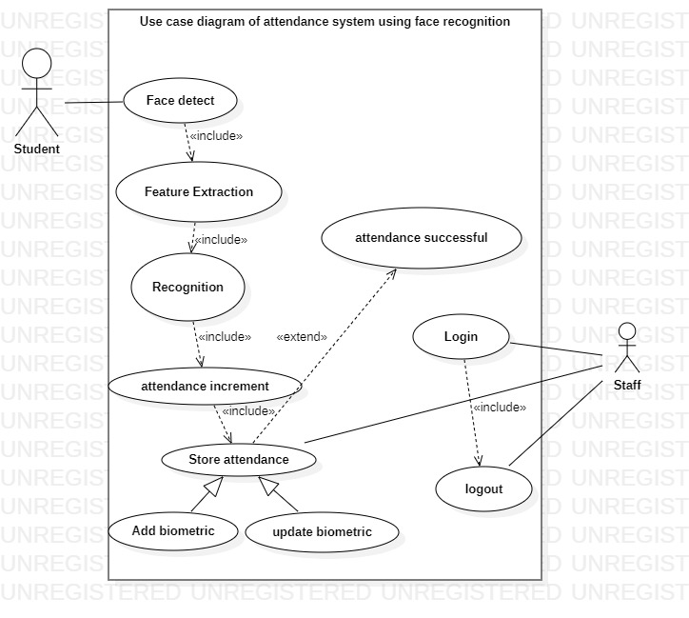

Fig 3.1 USE CASE DIAGRAM

Use case diagram. Fig [3.1] describe the use case diagram of attendance system. The student provides a biometric input of their face. The system extract feature from the biometric input that is used to recognize the user. After the user is recognized as a valid user then the attendance of the user is done. The time stamp is used to determine when the user attendance is done. The staff should login to perform attendance operation in the system. After the work of the staff is done then staff logs out.

## **3.3 Feasibility Study**

Feasibility study is a test of a system proposed according to its work ability, impact on the organization, ability to meet user needs and effective use of resources. The feasibility study of this application had been carried out which are as follows:

### **3.3.1 Technical Feasibility**

The web application is technically feasible. It complies with current technology including both the hardware and the software. The web application is supported by almost all latest web browsers and most of all it can run on modern day system.

### **3.3.2 Economic Feasibility**

The application we are building is a web based application that uses open sources. The system being developed is economic with respect to School or College’s point of view. All the required tools and techniques are provided online. The hosting of the application is run by local host. Hence no expenses are required in hardware as well as software aspect.

### **3.3.3 Legal Feasibility**

Students are required to give their biometric as input so without the permission of the user the data would not be provided to unauthorized organization or unauthorized users.

### **3.3.4 Operational Feasibility**

Since, the application is interactive, the user can easily be familiarized with the software system. This system highly focuses on parameters like reliability, maintainability, supportability, usability, sustainability, etc. that fits into the operating functions of the project. As the system is accessible with a web browser, it can be easily operated the desired functionalities, both by the user and the administrator.

#### **3.3.5 Schedule Feasibility**

The time interval of the project from starting to ending and all the activities done between is shown in following Gantt chart.

Fig:3.2 Gantt chart

|  |  |  |  |  |  |  |  |  |
| --- | --- | --- | --- | --- | --- | --- | --- | --- |
| **Day**  **Process** | **Nov**  **(15-30)** | **Dec**  **(1-15)** | **Dec**  **(15-31)** | **Jan**  **(1-15)** | **Jan**  **(15-31)** | **Feb**  **(1-30)** | **March**  **(1-30)** | **April** |
| **Analysis** |  |  |  |  |  |  |  |  |
| **Design** |  |  |  |  |  |  |  |  |
| **Implementation** |  |  |  |  |  |  |  |  |
| **Testing** |  |  |  |  |  |  |  |  |
| **Documentation** |  |  |  |  |  |  |  |  |
| **Presentation** |  |  |  |  |  |  |  |  |

## **3.4 Structuring System Requirements**

#### **3.4.1 Process Modeling**

Process modeling is a technique designed to understand and describe the process. It connects and improves the communication between the current and the future state of a process.

#### **Data Flow Diagram**

DFD shows how information is input and output from the system, the sources and destination of that information, and where that information is placed.

#### **Data flow diagram level 0**

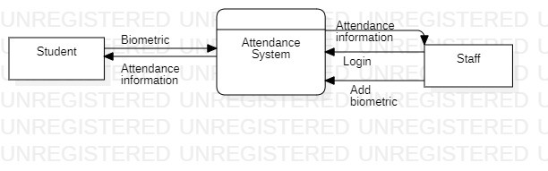

Fig 3.3 DFD LEVEL 0

The fig 3.3 DFD level 0 contains two entities user and admin. User provides biometrics to the attendance system and staff log in to the attendance system and the system provides required information to the staff. Similarly, the staff can add other biometrics as per the requirement.

#### **Data Flow Diagram level 1**

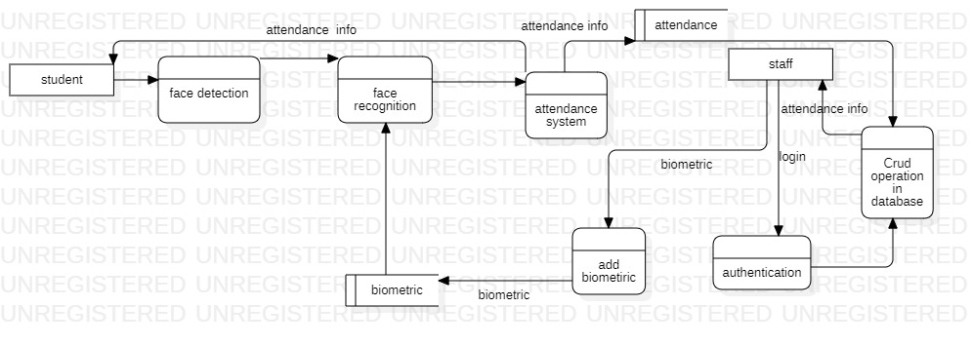

Fig 1.4 DFD LEVEL 1

A level-1 3.4 DFD notates each of the main sub-processes that together form the complete system. We can think of a level 1 DFD as an “exploded view” of the level 0 diagram. First the staff takes the biometrics of the user and saves it. The staff must login to make the change in the database. The student gives their biometrics to the system. Then system will detect and recognize the face and will be marked as attendance is done. Then system will give the attendance information back to the student.

# **CHAPTER 4: SYSTEM DESIGN**

## **4.1 Sequence Diagram**

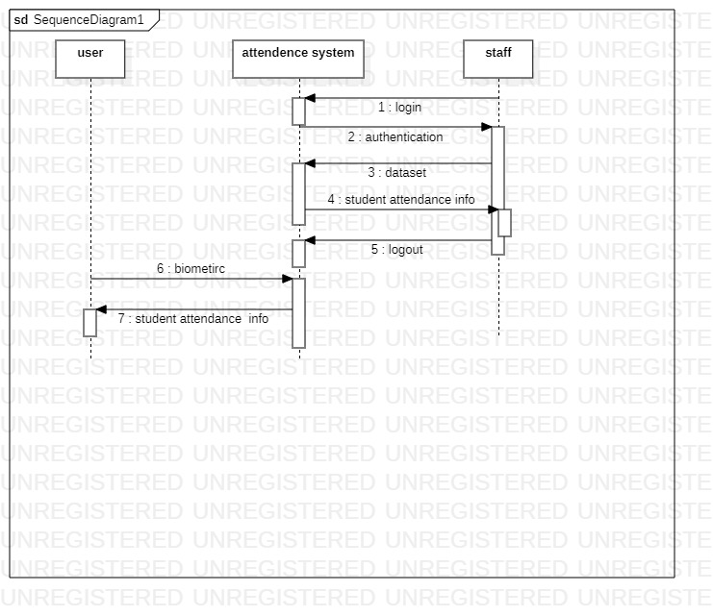

Fig 2.1 SEQUENCE DIAGRAM

Fig 4.1 denotes the interaction diagrams that detail how operations are carried out. The staff login to the attendance system. The system authenticates the staff. The biometric or data set to the attendance system by the staff. The user provides there biometric and attendance system update student attendance. The attendance system provides information to the user and the staff. The staff log out after the work is done.

#### **4.2 Algorithm**

Step 1: - Create a dataset.

Step 2: - Divide data into training and testing set

Step 3: - Build a model

Input layer: The input to the network is a 224x224 RGB image.

Convolutional layers: The first 2 layers have 64 filters with a 3x3 kernel size and a stride of 1. The next 3 layers have 128 filters with a 3x3 kernel size and a stride of 1. The next 3 layers have 256 filters with a 3x3 kernel size and a stride of 1. The next 3 layers have 512 filters with a 3x3 kernel size and a stride of 1. The last 2 layers have 512 filters with a 3x3 kernel size and a stride of 1.

Activation functions: All convolutional layers are followed by a ReLU activation function.

Max pooling layers: There are 5 max pooling layers with a 2x2 pool size and a stride of 2.

Flatten layer: The output from the last max pooling layer is flattened into a 1-dimensional vector.

Fully connected layers: There are 3 fully connected layers with 4096 units each.

Activation functions: All fully connected layers are followed by a ReLU activation function.

Output layer: The final output layer is a softmax layer with up to 1000 units, which outputs a probability distribution over 1000 different classes

Step 4: - Get input from user and recognize.

#### **4.3 Working principle:**

# **Face detection algorithm with Viola-Jones algorithm:**

Viola-Jones algorithm is applied for detecting the face in the image. Viola-Jones detector was chosen as a detection algorithm because of its high detection rate, and its ability to run in real time. Detector is most effective on frontal images of faces and it can cope with 45° face rotation both around the vertical and horizontal axis. The three main concepts which allow it to run in real time are the integral image, Ada Boost and the cascade structure. The Integral Image is an algorithm for cost-effective generation of the sum of pixel intensities in a specified rectangle in an image. It is used for rapid computation of Haar-like features. Calculation of the sum of a rectangular area inside the original image is extremely efficient, requiring only four additions for any arbitrary rectangle size. AdaBoost is used for construction of strong classifiers as linear combination of weak classifiers.

|  |  |  |
| --- | --- | --- |
|  |  |  |

|  |  |
| --- | --- |
|  |  |

2- rectangle feature 3- rectangle features

|  |  |
| --- | --- |
|  |  |
|  |  |

4- rectangle features

Fig4.1: Haar- Features in Voila -Jones Algorithm

The above Fig4.1 shows the Haar features that can be of various height and width. From the Haar feature applied to the face the sum of black pixel and sum of white pixel are calculated and they are subtracted to get a single value. If this value is more in that region, then it represents a part of the face and is identified as eyes, nose, cheek etc.

Haar features are calculated all over the image which will be almost 160000+ features per image. Summing up the entire image pixel and then subtracting them to get a single value is not efficient in real time applications. This can be reduced by using Ada boost classifier. Ada boost reduces the redundant features. Here instead of summing up all the pixels the integral image is used as shown in figure

|  |  |  |
| --- | --- | --- |
| 1 | 2 | 3 |
| 2 | 4 | 6 |
| 3 | 6 | 9 |

|  |  |  |
| --- | --- | --- |
| 1 | 1 | 1 |
| 1 | 1 | 1 |
| 1 | 1 | 1 |

Fig: 4.2 integral image

To get a new pixel value the top pixels and left pixels are added then all the values around the patch are added to obtain the sum of all pixel value.

Ada boost determines relevant features and irrelevant features. After identifying relevant features and irrelevant features the Adaboost assigns a weight to all of them. It constructs a strong classifier as a linear combination of Weak classifiers.

1; Identified a feature (example: nose)

Weak classifier =

0; Not Identified any feature (example: no nose in image)

Almost 2500 features are calculated. Further the number of computations can be reduced by cascading. Here set of features are kept in another set of classifier and so on in a cascading format. By this method one can detect whether it is a face or not in a quicker time and can reject it if one classifier fails to provide a required output to the next stage. The detected face is cropped and resized to a standard resolution of 100x100. The next step is to identify the detected image using convolutional neural network (CNN).

# **Face recognition using convolutional neural network**

A convolutional neural network can be used for face recognition system. Convolutional neural networks use images as input and convolution kernels, made up out of weights, as connections to the next layer. Convolutional neural network (CNN) is a feed-forwarding Artificial Neural Network applied for analyzing images, it's multilayer perceptron which doesn’t require data pre-processing. CNNs learn to extract features from images and use those features to classify the images into different categories. The depth of a CNN is important for facial recognition because it allows the CNN to learn more complex facial features.

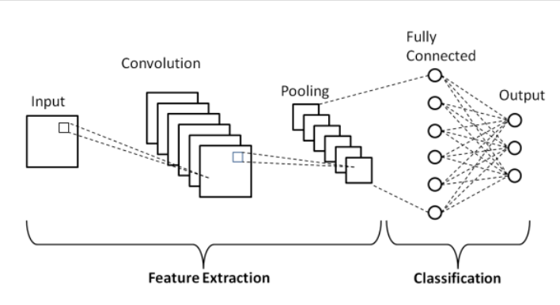

Fig 4.3: Convolutional neural network.

**1. Convolutional Layer**

This layer is the first layer that is used to extract the various features from the input images. In this layer, the mathematical operation of convolution is performed between the input image and a filter of a particular size MxM. By sliding the filter over the input image, the dot product is taken between the filter and the parts of the input image with respect to the size of the filter (MxM).

The output is termed as the Feature map which gives us information about the image such as the corners and edges. Later, this feature map is fed to other layers to learn several other features of the input image.

The convolution layer in CNN passes the result to the next layer once applying the convolution operation in the input. Convolutional layers in CNN benefit a lot as they ensure the spatial relationship between the pixels is intact

Forward propagation for convolutional layer is

$Y_{i}$ = ${ B}_{i}$ + $\sum_{j=1}^{n}{X_{j }}⋆K_{ij,}$ i=1…..d…………………………………………….(1)

Where Yi is the output matrix

Bi is the biases matrix

Xj is the input matrix

Kij is kernel matrix

Backward propagation for convolution layer is

$\frac{∂E}{∂K}$ = X $⋆ \frac{∂E}{∂Y}$…………………………………………………………………………..(2)

$\frac{∂E}{∂B}$ = $\frac{∂E}{∂Y}$………………………………………………………………………………...(3)

$\frac{∂E}{∂X}$ = $\sum_{i=1}^{n}{\frac{∂E}{∂Y}}$ $⋆(full)K_{ij}$……………………………………………………………..(4)

Where Kij is kernel matrix

**2. Pooling layer:**

Max Pooling operation involves sliding a 2- dimensional filter over each channel of features map and extract maximum features from image. Pooling layer used to reduce the dimension of feature map. It reduces the number of parameters to learn and amount of computation to perform. Pooling layer summarizes the feature present in a region of the feature map generated by the convolution layer.

**3.Flattening:**

All the values from different cells are stacked in one vector which becomes a feature to ANN. High numbers in the vector refers to specific features in the input image which represents the distinct feature of a face. The flattened matrix is fed as input to the fully connected layer

**4. Fully Connection Layer**

It is one of the fully feed forward neural network. It formed by last few layers. Once the image is convolved, pooled and flattened, the result is a vector. This vector act as the input layer for an ANN which then works normally to detect the image. It assigns random weights to each synapse; the input layer is weight adjusted and put in to an activation function. Every single neuron has a connection to every single neuron in next layer. The output is then compared with true values and the error generated is back-propagated, i.e., the weights are re-adjusted and all the processes repeated. This is done until the error is reduced or get correct output.

**4.Activation function**

The activation function decides whether a neuron should be activated or not by calculating the weighted sum and further adding bias to it. The ReLU is the most used activation function in the world right now. Since, it is used in almost all the convolutional neural networks or deep learning. The ReLU function performs a threshold operation on each input element where all values less than zero are set to zero.

#### **4.4 Network Architecture**

The 16 in VGG16 refers to 16 layers that have weights. In VGG16 there are thirteen convolutional layers, five Max Pooling layers, and three Dense layers which sum up to 21 layers but it has only sixteen weight layers i.e., learnable parameters layer.

Input layer with 224x224 RGB image.

Convolutional layer with 64 filters, 3x3 kernel size, stride of 1, and padding of 1

Convolutional layer with 64 filters, 3x3 kernel size, stride of 1, and padding of 1

Max pooling layer with 2x2 pool size and stride of 2

Convolutional layer with 128 filters, 3x3 kernel size, stride of 1, and padding of 1

Convolutional layer with 128 filters, 3x3 kernel size, stride of 1, and padding of 1

Max pooling layer with 2x2 pool size and stride of 2

Convolutional layer with 256 filters, 3x3 kernel size, stride of 1, and padding of 1

Convolutional layer with 256 filters, 3x3 kernel size, stride of 1, and padding of 1

Convolutional layer with 256 filters, 3x3 kernel size, stride of 1, and padding of 1

Max pooling layer with 2x2 pool size and stride of 2

Convolutional layer with 512 filters, 3x3 kernel size, stride of 1, and padding of 1

Convolutional layer with 512 filters, 3x3 kernel size, stride of 1, and padding of 1

Convolutional layer with 512 filters, 3x3 kernel size, stride of 1, and padding of 1

Max pooling layer with 2x2 pool size and stride of 2

There is a flatten layer that create a 1-dimensional vector.

fully connected layers with 2048 units each which is batch normalized and dropout layer is also applied.

fully connected layers with 1024 units each which is batch normalized and dropout layer is also applied.

The final output layer is a softmax layer with 3 units for now, which outputs a distribution over 3 different classes.

# **CHAPTER 5: IMPLEMENTATION AND TESTING**

# **5.1 Implementation**

# **5.1.1 Tools used**

For the development of this system various software tools were used but no any hardware tools were used in the development process.

**Front End:**

A “front-end” application is one that application users interact with directly. The front end is an interface between the user and the back end. In client/server project, the client part of the program is often called the front end and the server part is called back end. While creating a front end, different components relating to the software development were used. They are listed below :

* HTML is used to display the content of the website. It is a computer language devised to allow website creation.
* CSS is used to design and style the website.
* Tkinter is a python library used to make the desktop application using Python Programing language

# **Back End:**

A “Back-end” program serves indirectly in support of the front-end services, usually by being closer to the required resource or having the capability to communicate with the required resource.. It is the part of the system that normal users don’t want to know about it. System administrator manages it. Backend posse’s database and administrator, manages it. The following parts are contained in the backend of our system:

* SQL lite3 database is used to store the dataset and student information
* PHP is used to link the database and webpage
* Tensorflow is used to create the model

# **5.2 Testing**

# **5.2.1 Unit Testing**

At first each and every functional module is tested separately and the result of that module is analyzed. These tests are usually written by the developers of the module and after coding it was parallel tested and after getting bug it was made bug free.

Table5.1: Valid Registration Unit Table

|  |  |  |  |  |  |
| --- | --- | --- | --- | --- | --- |
| SN | Test Case | Input Test Data | Expected Result | Obtained Result | Test Status |
| 1 | Test If an registration is done with roll no and name | Roll no =2  Name=Bishwa  Fig 5.1: Test1 | No Error Message | Camera will open for registration  Fig5.2: Test2 | Pass |
| 2 | Test if an registration is done without roll no and name | Roll No =  Name =  Fig5.3: Test3 | Error Message | Please Enter Data  Fig5.4: Test3 | Pass |

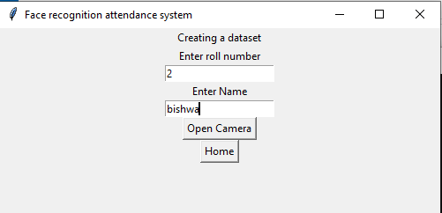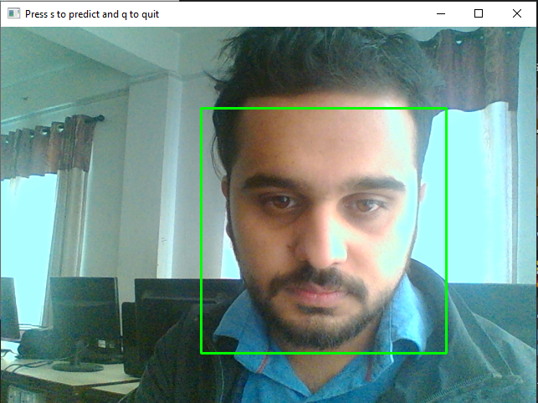

Fig 5.1: Test 1 Fig 5.2: Test 2

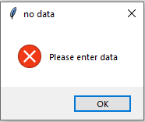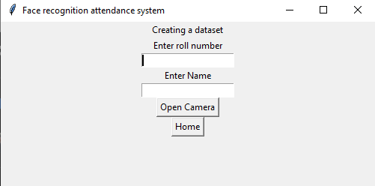

Fig 5.3: Test3 Fig 5.4: Test4

# **5.2.2 Integration Testing**

|  |  |  |  |  |  |
| --- | --- | --- | --- | --- | --- |
| SN | Test Case | Input Test data | Expected Result | Obtained Result | Test result |
| 1 | If camera window is open press P to take image | Press P | Take Image | Image is Captured  Fig5.5: Test5 | pass |
| 2 | Test if 300 image are captured | Student gives his/her face for input and press S to save | Capture 300 face image and save them in dataset folder | Dataset is created  Fig5.6: Test 6 | pass |

Table 5.2: Integration test of system

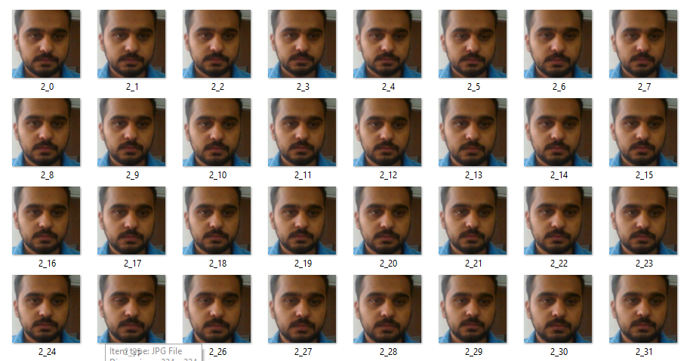Fig 5.5: Test 5 Fig5.6: Test6

Table 5.3: Integration test of system

|  |  |  |  |  |  |
| --- | --- | --- | --- | --- | --- |
| SN | Test case | Input Test Data` | Expected result | Obtain Result | Test status |
| 1. | Test if Predict button is clicked then camera opens | Predict button is clicked  Fig5.7: Test7 | Camera is open | Windows for camera is opened  Fig5.8: Test 8 | pass |
| 2. | Test if P is pressed then it predict the students and attendance is done | Image of student is given | Name and confidence of the student and database is updated | Database is updated  Fig5.9: Test9 | pass |
| 3. | Test if database is displayed and updated in the webpage | Data from predicted image | Database is shown in the webpage | Database is updated  Fig5.10: Test 10 | pass |

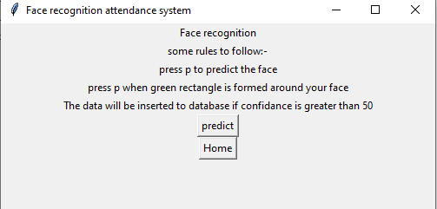

Fig5.7: test 7

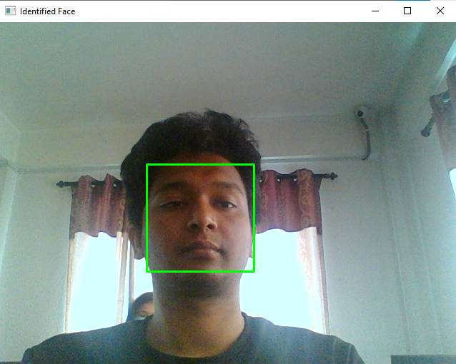

Fig5.8: Test8

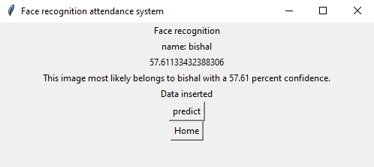

Fig5.9 Test 9

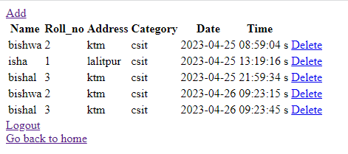

Fig5.10: Test10

# **5.2.3 System testing**

In system testing, integration testing passed components are taken as input. The goal of integration testing is to detect any irregularity between the units that are integrated together. System testing detects defects within both the integrated units and the whole system. The result of system testing is the observed behavior of a component or a system when it is tested. The system testing done for the project is:

* System admin enters roll no and name of Student.
* System admin takes image of Student and Trains image.
* If student is already into system, they needn’t train image again.
* If student is not into system, they need to train image.
* Student image must be trained to take automatic attendance.
* If already trained, admin takes automatic attendance of Student.
* If any mistakes occur admin will edit the database to web application.

# **5.3 Result Analysis**

In our project we created a VGG 16 model that can classify the image among 3 classes. The model takes the image as an input size of 224*224. The custom dataset of 3 classes Bishal, Bishwa, Isha are created. The total number of images in the dataset are 217. The validation split is 20%. It means that 80 percent of dataset is used for training and 20 percent is used for test.

We used 60 epochs to train and test our data during which the loss and accuracy is defined by the following graph.

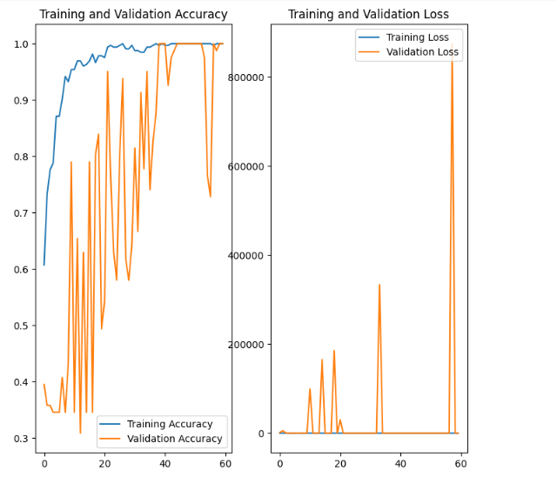

Fig 5.11: training accuracy of model

The training accuracy of the model increases as the epochs increases. There is a radical change in each epoch in validation accuracy. There is a minimum loss in training but there is a sudden loss of parameter.

The prediction of the data we take input from the webcam. Some output of the model is listed below: -

**Input: -**



Fig5.12: Without Haar-classifier

**Prediction: -**

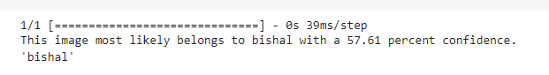



Fig 5.13: With Haar-classifier

**Prediction: -**





Fig 5.14: Without Haar- Classifier

**Prediction: -**

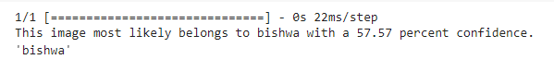



Fig5.15: With Haar-Classifier

**Prediction: -**



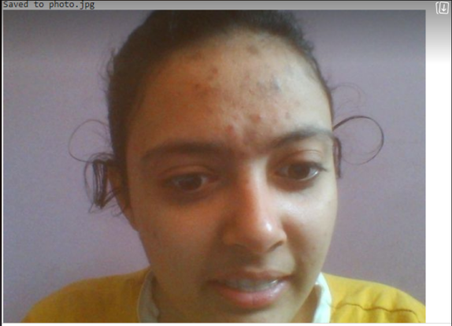

Fig5.16: Without Haar-classifier

**Prediction:**

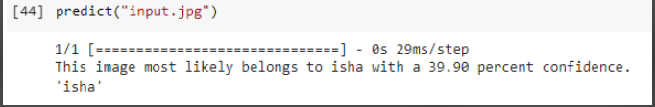



Fig5.17: With Haar-classifier

**Prediction:**

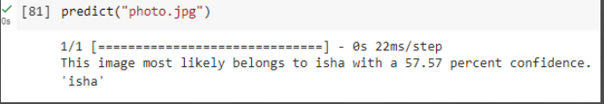

The different dataset of 3 classes are given below:

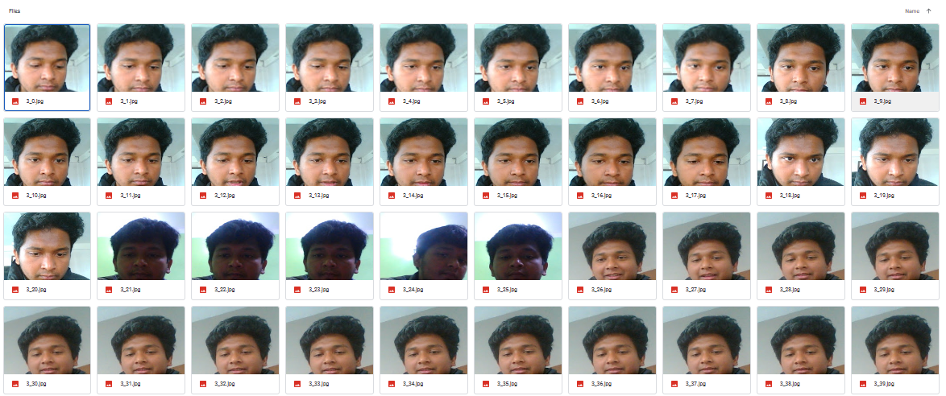

Fig 5.18: Dataset of Bishal

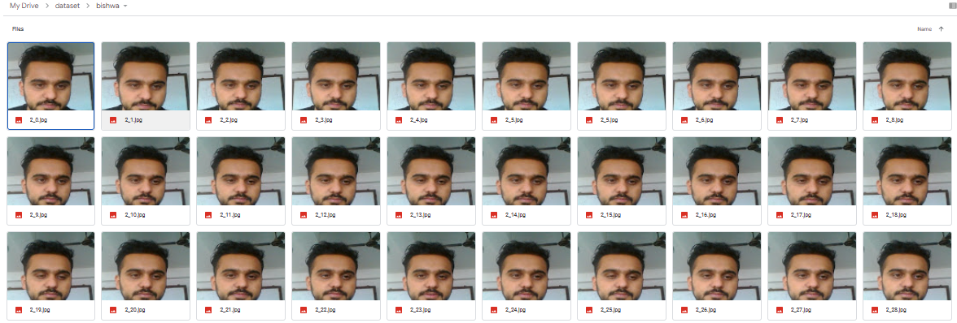

Fig 5.19: Dataset of Bishwa

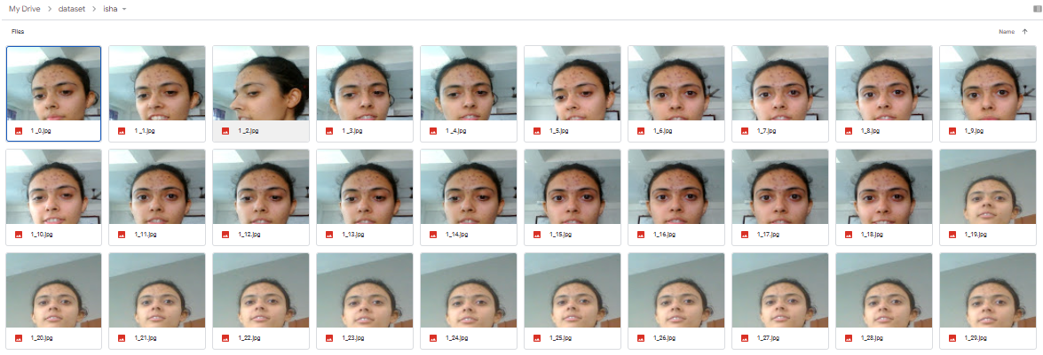

Fig: 5.20: Dataset of Isha

The database is used to store information of the student. This information is later used during attendance. If the confident is less than 50 then the attendance is not done else attendance of the student is stored in the second database.

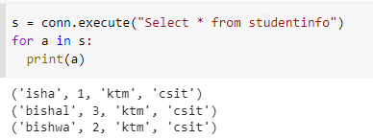

Database named student info have 3 data. The data is the used for attendance.

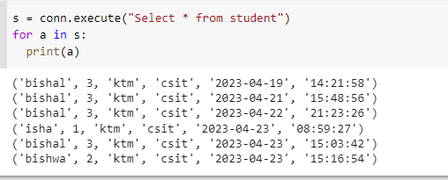

The database student is used to store the attendance. The database store name, roll no,address, Department, date and time of the attendance.

# **CHAPTER 6: CONCLUSION AND RECOMMENDATION**

## **6.1 CONCLUSION**

Thus we have completed the attendance system using the face detection process. This is the automatic attendance system which overcome the difficulties occur in the manual attendance system and also saves the time and effort for attendance process. This system uses the VGG-16 architecture. The VGG-16 is a well-established and highly effective architecture for image classification and other computer vision.

Although there are some limiting conditions as the detection was clear and more accurate at the bright light room and detection was not suitable at the dark room. As the Haar cascade method is based more on contrast values rather than the pixel intensities of the image, contrast and the brightness of the face and also the background should be as required and suitable for the system. The rate of detection was also varying with the resolution, quality of the camera and the total number of data set in training and test set.

## **6.2 RECOMMENDATION**

The system can be made more flexible and scalable using these recommendations.

* The system can be extended to more number of students to change the list of students as the class changes.
* A stream of consecutive images is required for the live face detection.
* The system can also be extended to allow better face recognition algorithm in which even rotational features of face can be detected efficiently.

# **References**

[1] S. Saypadith and S. Aramvith, "Real-Time Multiple Face Recognition using Deep Learning on Embedded GPU System", 2018 Asia-Pacific Signal and Information Processing Association Annual Summit and Conference (APSIPA ASC), Honolulu, HI, USA, pp. 1318-1324, 2018. doi:10.23919/APSIPA.2018.8659751

[2] D Mery, I. Mackenney and E. Villalobos, "Student Attendance System in Crowded Classrooms Using a Smartphone Camera", 2019 IEEE Winter Conference on Applications of Computer Vision (WACV), Waikoloa Village, HI, USA, pp. 857-866, 2019. doi: 10.1109/WACV.2019.00096.

[3] M. A. Rahman and S. Wasista, “Sistem Pengenalan Wajah Menggunakan Webcam Untuk Absensi Dengan Metode Template Matching,” Jur. Tek. Elektron. Politek. Elektron. Negeri Surabaya, pp. 1–6.

[4] E Indraetal., “Design and Implementation of Student Attendance System Based on Face Recognition by Haar-Like Features Methods," 2020 3rd International Conference on Mechanical, Electronics, Computer, and Industrial Technology (MECnIT), Medan, Indonesia, pp. 336-342, 2020. doi: 10.1109/MECnIT48290.2020.9166595

[5] P. Kowsalya,J. Pavithra, G. Sowmiya and C.K. Shankar. “Attendance monitoring system using face detection & face recognition”, International Research Journal of Engineering and Technology (IRJET),vol. 06, no. 03, pp. 6629-6632, March 2019. ISSN: 2395-0072.

[6] http://www.saitm.edu.lk/fac_of_eng/RSEA/SAITM_RSEA_2013/imagenesweb/10.

[7] Ra, D.(2011). A real time face recognition using PCA and various distance classifiers. Indian Institute of Technology, Computer science and engineering, Kanpur, retrieved from hhttp://www.academia.edu

[8]<http://www.frvt.org/>

[9]<http://vision.uscd.edu/> leekc/ExtYaleDatabase/ExtYaleB.html

# **APPENDICES:**

UI to create data set or take attendance.

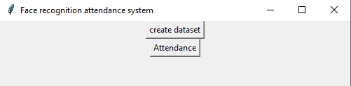

To create a dataset:-

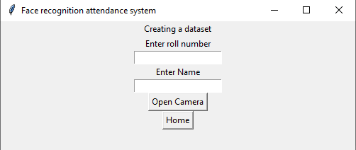

Enter a roll no and enter name and press open camera :-

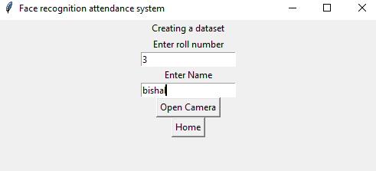

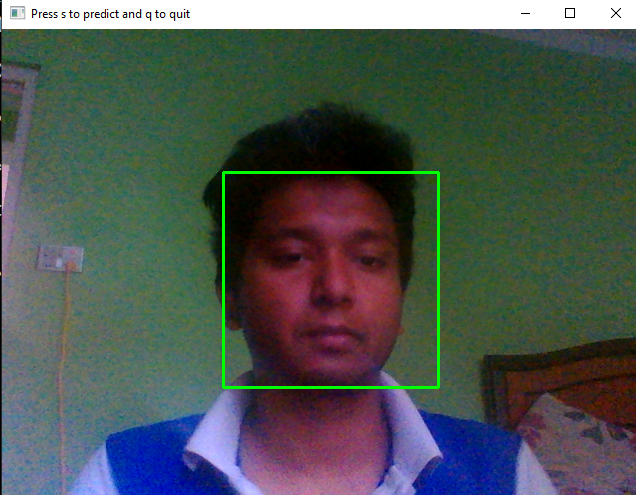

To take the attendance of the user:

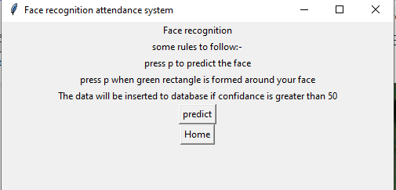

Click on predict to get the attendance: -

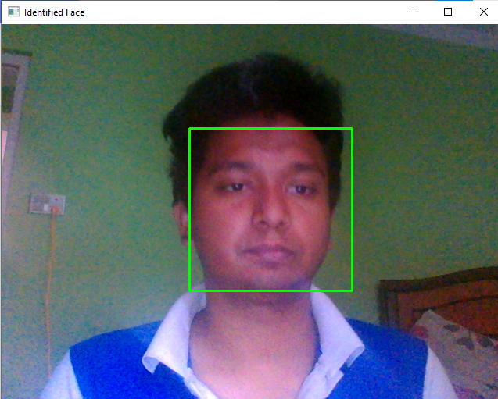

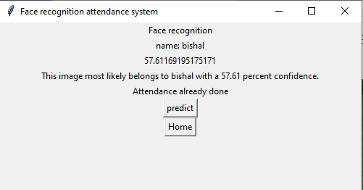

Web application for Admin: -

To register: -

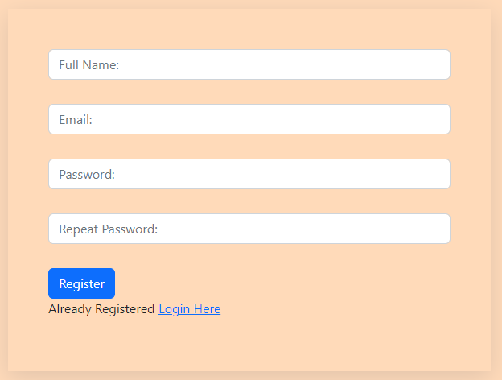

For login: -

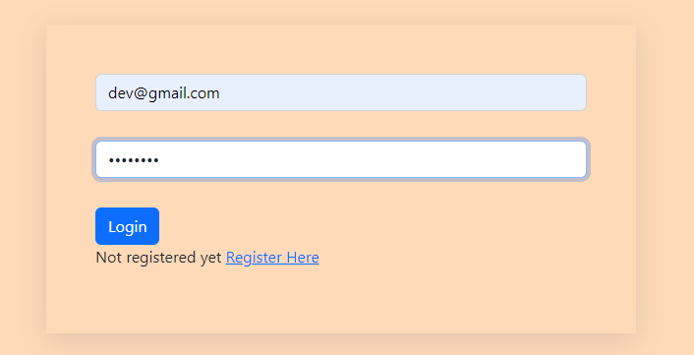

Home page: -

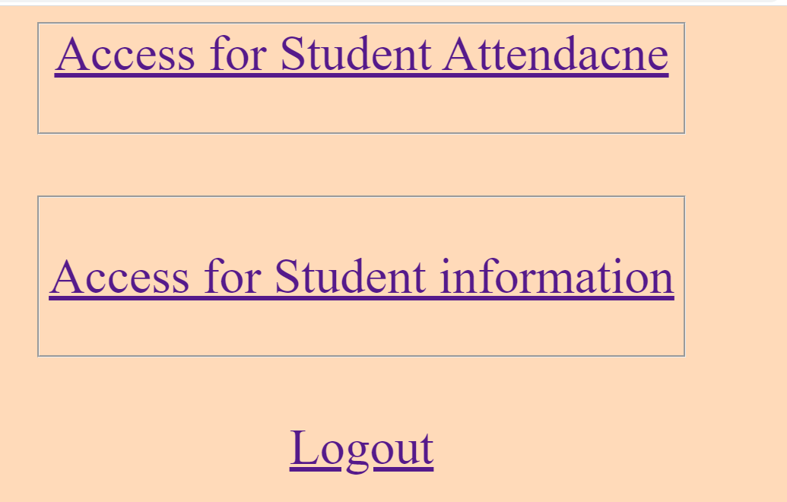

After clicking on Student information: -

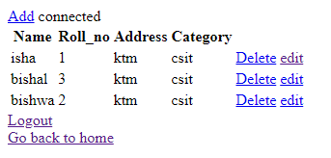

The Attendance of student: -

